This update is provided by the Somerset Covid-19 Engagement Board and is designed to provide a weekly update on the current Covid-19 situation in Somerset.
Thursday 28 January 2021
Somerset’s Covid-19 Weekly Update

This week, the second of Somerset’s large vaccination centres, based at the Bath and West Showground, has started to vaccinate local residents and frontline heath and care workers from the highest priority groups. This is great news for the County, and for those who are being called to have their vaccination, please step forward for it; for those in the priority groups that haven’t yet heard, you will do very soon.
The vaccination is part of our toolkit; one tool won’t get the job done by itself, we need to use everything we’ve got and we can’t rely solely on the vaccine, the essential hands face space guidance really is so important, as is following the stay home guidance and isolating correctly if you display symptoms are test positive for the virus.

The vaccine designed to prevent serious illness and death from Covid-19, even if you have had the vaccine, you can still catch it and might still be able to pass it on to others so the hands face space guidance must still be followed to protect yourselves and others.

‘Remember, everyone can catch it, anyone can spread it’.

Clare Paul, Cabinet Member for Public Health and Wellbeing
Twitter: @Clarepaul_

Trudi Grant
Director of Public Health
Twitter: @SomersetDPH

David Fothergill
Leader of
Somerset County Council
Twitter: @DJAFothergill

Along with the rest of the UK, locally we are seeing rates coming down, however figures are still high, and Covid-19 is still very much circulating in our communities.

Somerset’s seven-day infection rate has decreased considerably from last week’s rate of 305.4 and now stands at 255.2 new cases per 100,000.
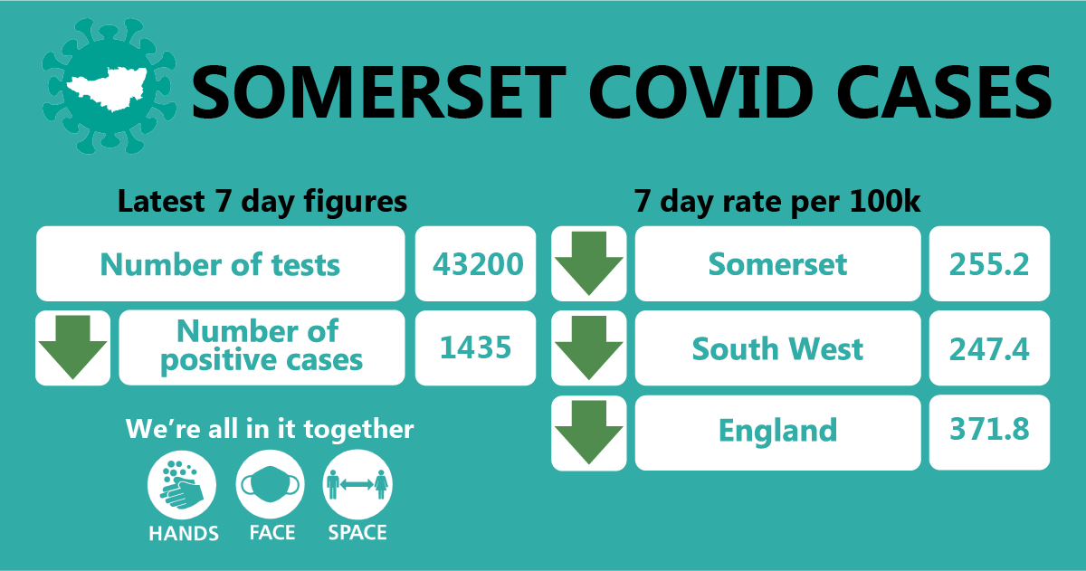

Between 17 and 23 January, approximately 43,200 tests were carried out across the county and there has been 1,435 new confirmed cases. The number of tests has increased due to the ramp up of testing (in particular, the rapid testing programme) but importantly, the number of positive cases has reduced since last week’s update.
The link below shows the Somerset Dashboard which tracks our local epidemic from the start in March, to the current time:

https://www.somerset.gov.uk/covid-19-dashboard/

Workplaces: We continue to see outbreaks occurring as people socialise in and around the workplace (where people cannot work from home) and unfortunately, have seen a number of significant outbreaks in the food sector. Some common factors being seen in these situations include people car-sharing and the particular challenges posed by chilled indoor working environments. We are continuing to provide these settings with Public Health advice, support and guidance on prevention measures.

We have produced a number of communications materials that have been shared with businesses to reinforce the importance of keeping up infection control measures even in informal settings such as lunch breaks.

Care Sector: In the seven days between 17 and 23 January, there were 244 new cases at 50 care home settings. The positive cases identified were staff and residents; we continue to support these settings with support and guidance on prevention measures.

We are extremely pleased that the majority of care home residents have now received their first vaccination, helping to prevent serious illness from Covid-19 within this group.

Schools and Early Years settings: The national lockdown means that only vulnerable children and those of key workers can attend school, with all other learning being conducted online.

Somerset schools are working hard to implement the Department for Education mass testing programme. This means staff and pupils in secondary and special schools will have access to rapid testing kits if they are on site. As of Monday 25 January, all staff at primary schools and maintained nursery settings now have access to rapid testing kits.

Communications:

Stay at home restrictions
We remain under a period of national lockdown, and as before, encourage you to share the following poster with your networks to help explain the restrictions: England Lockdown: Stay At Home posters - GOV.UK (www.gov.uk)

Covid-19 vaccine safety
Our Director of Public Health Trudi Grant’s own mother had her turn for her first dose of the vaccine this week – watch it here.

We are aware that there are myths circulating around the Covid-19 vaccine and a natural hesitancy amongst communities to receive the jab. It is important to remember that the NHS would not offer any Covid-19 vaccinations to the public until it was safe to do so. The MHRA - the official UK regulator authorising licensed use of medicines and vaccines by healthcare professionals, has made this decision, and we have full confidence in their expert judgement and processes.

It was very clear that this was a global public health emergency from the word go and governments were prepared to put in lots of funding to manufacturers, without any guarantee of success, but hoping that they would find a solution

Manufacturers knew this had to be a straight run through, they didn't have time for investment decisions and pausing or thinking about a commercial market at the end of it. It had to happen with real urgency.

The vaccine trials have been just the same as normal vaccine trials. Phase one, phase two and phase three. Where time has been saved is by recruiting participants in advance, so at the moment the study protocol was in place, the Ethics Committee was in place, so were the vaccine trial participants – which sped up the process. This happened at phase one, phase two and phase three and therefore things ran very fast.

Is your household Covid-19 safe?
When you’re at home with people you know well, we know that it feels strange to do the things needed to keep the virus out, but with one in three people carrying the virus without having symptoms, doing these things every day will really help:
- Regularly wash hands with soap and water for 20 seconds
- Wipe down surfaces that are touched a lot, such as phones, remote controls, door handles and bannisters
- Kept at least two metres apart from others where possible when outdoors on essential trips or exercise
- Avoid touching your face, eyes, nose or mouth with unwashed hands
- Regularly let fresh air into the home - open windows a few times a day
- If away from home, carry hand sanitiser and wear a face covering*
*this doesn’t apply to anyone who is medically exempt
- If you cough or sneeze, do so into a tissue (or your elbow if no tissue is available) and dispose of the tissue.
- Avoided sharing things like towels, cutlery and crockery
Advisory Network survey
Thank you to those of you that have signed up to be part of our Health and Wellbeing Advisory Network. We have today, launched a survey that has been designed specifically for members of the Network to help us deepen our understanding of the local picture across the county. We have already undertaken wide reaching communications and consultations to understand barriers and issues people may be facing in relation to Covid-19, but the Network’s insights on the groups that they work with/support will put us in a better position to address issues in different areas of the community.

If you are a member of the network, please do take part in the survey (you will have received an email). It should just take a few minutes of your time, if you haven’t yet joined the Network but would like to do so, please sign up here.
As always, please do keep an eye our Healthy Somerset website, which has a huge amount of information and resources to help keep everyone healthy happy and safe at this time: https://www.healthysomerset.co.uk/covid-19/

Finally, please like us on Facebook, follow us on Twitter and share our posts with your networks to help us in communicating these important messages. Follow our Director of Public Health account too here.

Resources and further information: For the latest local information as well as digital resources, posters and flyers please visit: https://www.somerset.gov.uk/coronavirus/

The Somerset Local Outbreak Management Plan outlines how we, the council, will work with the NHS Test and Trace Service, PHE, the NHS and other partners to ensure a whole system approach to preventing and managing local outbreaks. This can be found here.

