6th October 2021
All meetings are normally open to the Public and Press

To: All Members of Hemington, Hardington & Foxcote Parish Council
Dear Councillor
You are summoned to a meeting of the Hemington, Hardington & Foxcote Parish Council on Wednesday 13th October at 7.30 pm. The meeting will be held at Hemington School.
The meeting will consider the items set out below.
J A Gregory

Jennifer Gregory
Parish Clerk
Before the meeting there will be a public session to enable the electorate of Hemington, Hardington & Foxcote Parish to ask questions or make comments. Questions not answered at this meeting will be answered in writing to the person asking the question or may appear as an agenda item for the next meeting. Members of the public are asked to address the Chair with their question and please restrict their comments and/or questions to 15 minutes. Member of the Press and public will be excluded if the Parish Council by resolution enters a confidential session

A G E N D A

- Apologies for absence and to consider reasons given
1.1 Council to receive apologies for absence and, if appropriate, to resolve to approve the reasons given.

- Declarations of Interest and Dispensations
2.1 Members to declare any interest they may have in agenda items in accordance with the Council’s Code of Conduct.
2.2 To receive written requests for dispensation for disclosable pecuniary interests.
2.3 To grant any dispensation as appropriate.

- Minutes of the previous meeting held
3.1 To confirm and sign as a correct record the minutes of the meeting held on 8th September 2021

- Reports
4.1 To receive the District Councillor’s Report
4.2 To receive the Chairman’s report
4.3 To receive the Clerk’s Report (circulated)

- Planning Applications for consideration
5.1 To consider the following planning applications:
Ref | Proposal | Site | Closing Date
2021/1746/LBC | Replacement of existing garden room with the erection of an oak framed garden room | Chapel Farm Faulkland | 12.10.21
In view of the time constraint the Council through email agreed to support this application

5.2 To receive updates on planning decisions:-
Ref | Proposal | Site | Decision Date
2021/1577/FUL | Conversion of existing barn outbuilding to a single storey dwelling | The Barn, Cherry Garden Lane, Laverton | 22.09.21
Decision: Appeal Dismissed

- Play Area
6.1 To receive updates on regular play inspection and any maintenance tasks
6.2 Update on quotations for new play equipment
6.3 Concrete pad/Septic tank lid on playground

- Finances
7.1 Payment schedule as follows including payments made retrospectively for September:

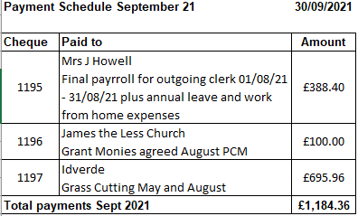

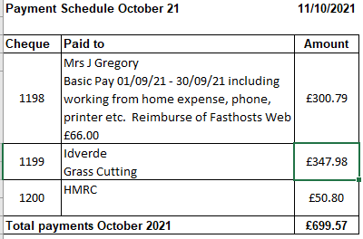

7.2 Bank Reconciliation current balance as at 30th September (to include reserve account) total £14050.65

- Traffic/Highways/Other
8.1 Consider an increase size of AMPR signage
8.2 Dog Bins – to consider whether additional are needed.

- Correspondence
9.1 Residents letter reference overgrown footpaths
9.2 SCC Covid 19 update
9.3 Newsletter- local neighbourhood policing team
9.4 Thank you email from St James the Less
9.5 Bus Service – from District Councillor
9.6 MDC – newsletter supporting farmers
9.7 MDC – newsletter grants

- Any Other business

- Matters of Report and Items for next meeting.

- Date of next meeting

- Close

