Hemington, Hardington
& Foxcote Parish Council
Chairman: Mark Corney 01373 834820 mark.corney@hemington-pc.org
Clerk: Jen Gregory 07912177288 clerk@hemington-pc.org.uk

M I N U T E S
Of Hemington, Hardington & Foxcote Parish Council
Held on Wednesday 13th October 2021 at Hemington School

Present: Chair M Corney, Cllrs F Green, M Francis

Also Present: J Gregory Proper Officer plus 2 members of the public

Public Participation
The Chairman welcomed everyone to the meeting. No matter was raised by members of the public.

10/21.22 077 Apologies for absence
Cllrs V Curtis, M Hanley and T Hucker gave apologies.
Resolved: apologies were accepted.

10/21.22 078 Declarations of Interest
Members were asked to advise any Declarations of interest in today’s agenda items or any pecuniary interests in line with Councils’ Code of Conduct.
Resolved: It was noted that no declarations, pecuniary or otherwise were received.

10/21.22 079 Minutes of the Previous Meeting
To receive the minutes of the meeting held 8th September.
Resolved: Minutes of the previous meeting was signed by the Chairman as a correct record in the presence of the Proper Officer and meeting attendees.

10/21.22 080 Reports
a. To receive the District Councillors Report
Unfortunately Cllr Barkshire gave apologies for non attendance, but her emailed report was read detailing high numbers of COVID especially in the Frome area, planning matters involving the local Plan part II and the acceptance of a requirement of 505 in NE of Mendip with some further development in Norton St Philip. A joint Committee of the 5 council leaders had been set up regarding the unitary authority. Consultee Access for planning was available and Hemington had joined this system. Parish Forums would be held 9th November, 14th December, 11th January and 8th February and March.

b. To Receive the Chairman’s Report
The Chair reported on an email received from Tim Gibbs at AutoSpeedWatch indicating the Mark Shelford view on AutoSpeedWatch and the fact that some data was being accepted by Wiltshire.

c. To Receive the Clerk’s Report
The Clerk advised the following:
Actions from the previous meeting had been instigated which included reporting the Dog bin at Bishops Street – it was unclear if this had been addressed however the Chairman would report to the Clerk further.

The Freedom of Information request had been done there had been no response and would be chased early next week.

The Royal Mail stated that the replacement of the Turner’s Tower mailbox was ongoing and that they could not provide a date for replacement as yet.

Grit bin status for the village had been advised to Mendip for cyclical replenishment.

10/21.22 081 Planning Applications for Consideration
The following application had been received with a response date prior to the meeting. An online discussion was had amongst council members.
Ref | Proposal | Site | Closing Date
2021/1746/LBC | Replacement of existing garden room with the erection of an oak framed garden room | Chapel Farm Faulkland | 12.10.21
In view of the time constraint the Council through email agreed to support this application

To receive updates on planning decisions:-
Ref | Proposal | Site | Decision Date
2021/1577/FUL | Conversion of existing barn outbuilding to a single storey dwelling | The Barn, Cherry Garden Lane, Laverton | 22.09.21
Decision: Appeal Dismissed

10/21.22 082 Play Area
In the absence of Cllr Hucker, the Chair reported that another play equipment company (Sutcliffe Play) had been approached for quotations. It was suggested that the play area move to its previous location inside the hedge on the road.
Resolved: It was agreed to re-establish the play area in its original location.

The septic tank cover had also been inspected by Cllr huck who proposed the Council invest in a cast iron heavy duty inspection cover.
Resolved: Cllr Hucker to look into and report back on costs.

10/21.22 083 Finances
The following payment schedules were agreed:
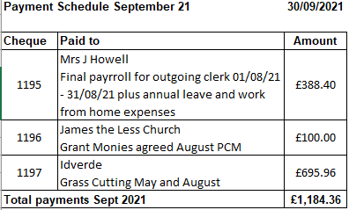

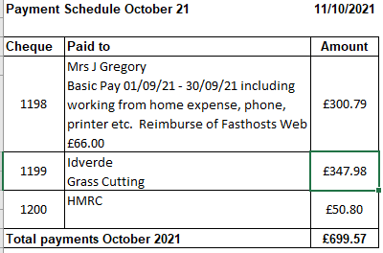

Bank Reconciliation current balance as at 30th September (to include reserve account) total £14050.65

10/21.22 084 Traffic/Highways
With Tim Gibbs from AutoSpeedWatch present the cost of increased size signage was requested. It was in the region of £47.90 per sign.
Resolved: Agreed for the Clerk to arrange costs formally with AutoSpeed Watch

Many of the signs in the village were looking worn, tatty and faded. It was suggested that Highways make an inspection of and report further
Resolved: The Clerk to arrange an Inspection from Highways of signage

There was discussion about dog bins, the state of the one on Bishop Street would be advised to the Clerk but another bin was considered and its location.
Resolved: The Clerk to source dog bin costings, and its location would be the North side of Grove Lane meeting with the bridleway. The Chair would report to the Clerk the state of the bin at Bishop Street

10/21.22 085 Correspondence
The following had been circulated to members prior to the meeting
Residents letter reference overgrown footpaths (plus further email correspondence today)
SCC Covid 19 update
Newsletter- local neighbourhood policing team
Thank you email from St James the Less
Bus Service – from District Councillor
MDC – newsletter supporting farmers
MDC – newsletter grants
Resolved: The Clerk to address concerns raised by resident and report action

10/21.22 086 Information / Items to Raise for consideration at the next meeting
Cllr Hanley had asked for the reconsideration of deflibulator machine situated on the outside of the pub.
Resolved: Clerk to investigate costs

Cllr Green asked if the lying water at Rutley Ford could be reported as recently a car hit the water and went through the hedge noting this wasn’t the first time.
Resolved: Cllr to contact Highways; drainage issue

10/21.22 087 Any Other Business
The Chair advised that the trees were on their way and we hoped to have them prior to the 12th November. A couple of weekend plantings were muted with villagers and families hopefully getting involved and the trees would be sited at the northern edge of the playing field with Faulkland Farm taking any surplus. Cllr Hucker would provide the water and the supply of such may be in tact at the field. Promotion on facebook and website would start but dates unknown at this stage
Resolved: Promotion of planting weekends through social media

10/21.22 088 Date of next Meeting
The next meeting would be held on the 10th November at Faulkland Village Hall

10/21.22 089 Close
The Chairman thanked all those present for their time and contribution and closed the meeting.

Meeting closed at 8.05pm

A signed copy of the minutes can be viewed by arrangement via the Parish Clerk and on its website.

