30th April 2022
All meetings are normally open to the Public and Press

To: All Members of Hemington, Hardington & Foxcote Parish Council
Dear Councillor
You are summoned to a full council meeting of the Hemington, Hardington & Foxcote Parish Council on Wednesday 8th June 2022 at 7.30 pm. The meeting will be held at Faulkland Village Hall
The meeting will consider the items set out below.
J A Gregory

Jennifer Gregory
Parish Clerk
Before the meeting there will be a public session to enable the electorate of Hemington, Hardington & Foxcote Parish to ask questions or make comments. Questions not answered at this meeting will be answered in writing to the person asking the question or may appear as an agenda item for the next meeting. Members of the public are asked to address the Chair with their question and the public session will be restricted to 15 minutes in total. Member of the Press and public will be excluded if the Parish Council by resolution enters a confidential session

A G E N D A

- Apologies for absence and to consider reasons given
1.1 Council to receive apologies for absence and, if appropriate, to resolve to approve the reasons given.

- Declarations of Interest and Dispensations
2.1 Members to declare any interest they may have in agenda items in accordance with the Council’s Code of Conduct.
2.2 To receive written requests for dispensation for disclosable pecuniary interests.
2.3 To grant any dispensation as appropriate.

- Minutes of the previous meeting held
3.1 To confirm and sign as a correct record the minutes of the meeting held on 11th May

- Reports
4.1 To receive the District Councillor’s Report
4.2 To receive the Chairman’s report
- Planning Applications for consideration
5.1 To consider the following planning applications: None as at 31.05.22

5.2 To receive updates on planning decisions: None as at 31.05.22

- Play Area
6.1 To receive updates on regular play inspection and any maintenance tasks
6.2 Concrete pad/Septic tank lid on playground (check if complete)

- Finances
7.2 To receive finance schedule for the month.

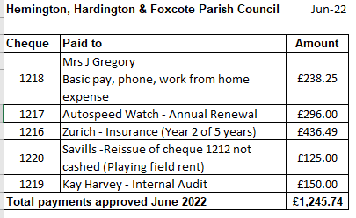
7.3 Cashbook figure 30.04.22 £24,402.82 including precept received £14569.00 and VAT reclaim £428.59.

7.4 Recommend Savills cheque from March to be re-issued on the basis the Clerk has checked with the Savills and this has not been received (included in finance schedule)

  - To approve Accounts for YE 2021/22

  - To approve and sign off AGAR document for 2021/22

  - To note the “Notice of Public Rights and Publication of Annual Governance & Accountability Return (Exempt Authority) period of inspection running from 13th June to Friday 22nd July

  - Signatories to sign Digital and Direct Banking and Business Application Form (enabling the Clerk online access to pay bills and download bank statements)

- Traffic/Highways/Other
8.1 To consider any areas to set aside from mowing.

- Correspondence
9.5 Approval of Code of Conduct (document circulated)
9.6 Rewilding scheme – Pollination for bees – Wells pilot

- Any Other business

- Matters of Report and Items for next meeting.

- Date of next meeting
12.1 Wednesday July 13th 2022 at 7.30pm

- Close

