1st December 2021
All meetings are normally open to the Public and Press

To: All Members of Hemington, Hardington & Foxcote Parish Council
Dear Councillor
You are summoned to a full council meeting of the Hemington, Hardington & Foxcote Parish Council on Wednesday 8th December at 7.30 pm. The meeting will be held at Faulkland Village Hall
The meeting will consider the items set out below.
J A Gregory

Jennifer Gregory
Parish Clerk
Before the meeting there will be a public session to enable the electorate of Hemington, Hardington & Foxcote Parish to ask questions or make comments. Questions not answered at this meeting will be answered in writing to the person asking the question or may appear as an agenda item for the next meeting. Members of the public are asked to address the Chair with their question and please restrict their comments and/or questions to 15 minutes. Member of the Press and public will be excluded if the Parish Council by resolution enters a confidential session

A G E N D A

- Apologies for absence and to consider reasons given
1.1 Council to receive apologies for absence and, if appropriate, to resolve to approve the reasons given.

- Declarations of Interest and Dispensations
2.1 Members to declare any interest they may have in agenda items in accordance with the Council’s Code of Conduct.
2.2 To receive written requests for dispensation for disclosable pecuniary interests.
2.3 To grant any dispensation as appropriate.

- Minutes of the previous meeting held
3.1 To confirm and sign as a correct record the minutes of the meeting held on 10th November

- Reports
4.1 To receive the District Councillor’s Report
4.2 To receive the Chairman’s report
4.3 To receive the Clerk’s Report (circulated)

- Planning Applications for consideration
5.1 To consider the following planning applications: 1

2021/2508 | Erection of front extension to existing garage | 3 Lavendar Close, Faulkland | Deadline 14.12.21

5.2 To receive updates on planning decisions: None as at 01.12.21

- Play Area
6.1 To receive updates on regular play inspection and any maintenance tasks
6.2 Update on quotations for new play equipment to tie in with item 7.5 budget and precept
6.3 Concrete pad/Septic tank lid on playground

- Finances
7.2 To receive finance schedule for the month.
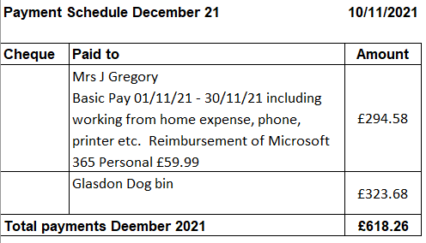
7.3 Update on online banking
7.4 Reconciliation as at 30.10.21 bank accounts are £9448.33 and £3504.06 in the business reserve with £530.20 in unpresented cheques made up from idverde and SALC
7.5 To consider budget figures and precept for next year.
7.6 To consider internal Auditor for the 2020/21 year (see point 9.3)

- Traffic/Highways/Other
8.1 Update of AMPR Signage
8.2 Dog Bins – new bin update

- Correspondence
9.1 Hassage Grit Bin
9.2 Public Announcement Re Avian Flu
9.3 Bridget Bowen resignation as Internal Auditor
9.4 Somerset SCO draft text reference LGA

- Any Other business

- Matters of Report and Items for next meeting.

- Date of next meeting

- Close

