5th June 2023
All meetings are normally open to the Public and Press

To: All Members of Hemington, Hardington & Foxcote Parish Council
Dear Councillor
You are summoned to a full council meeting of the Hemington, Hardington & Foxcote Parish Council on Wednesday 14th June 2023 The meeting will be held at Faulkland Village Hall.
The meeting will consider the items set out below.
J A Gregory

Jennifer Gregory
Parish Clerk
Before the meeting there will be a public session to enable the electorate of Hemington, Hardington & Foxcote Parish to ask questions or make comments. Questions not answered at this meeting will be answered in writing to the person asking the question or may appear as an agenda item for the next meeting. Members of the public are asked to address the Chair with their question and the public session will be restricted to 15 minutes in total. Member of the Press and public will be excluded if the Parish Council by resolution enters a confidential session

A G E N D A

- Apologies for absence and to consider reasons given
1.1 Council to receive apologies for absence and, if appropriate, to resolve to approve the reasons given.

- Declarations of Interest and Dispensations
2.1 Members to declare any interest they may have in agenda items in accordance with the Council’s Code of Conduct.
2.2 To receive written requests for dispensation for disclosable pecuniary interests.
2.3 To grant any dispensation as appropriate.

- Minutes of the previous meeting held
3.1 To confirm and sign as a correct record the minutes of the meeting held on 24th May 2023

- Matters Arising / Updates
4.1 Septic Tank Lid
4.2 Traffic Matters including complaint
4.3 Laverton Lorry
4.4 Play Park
4.5 Pond
4.6 Stables
4.7 Banking Arrangements – Paper attached
4.8 Traffic Action Group
4.9 Hemington Church Grant – 6 monthly review

5. Reports
  - To receive the Count/District Councillor’s Report
  - To receive the Chairman’s report

6. Planning Applications for consideration
  - Planning Matters for discussion:

Application Two storey single storey side rear extension Location: Rose Cottage Faulkland To Norton St Philip Road Faulkland Frome Somerset Applicant: Ms Patsy Mehring Application Type: Householder Application Application Number: 2023/0880/HSE

7. Play Area
  - Fencing options – Quotation circulated. Further quotes to be sourced.

8. Finances
8.1 To receive finance schedule for the month.
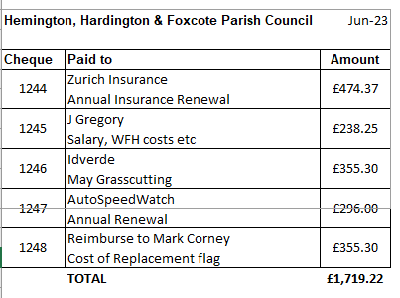

8.2 Balance on Accounts as at 30.04.23 £40663.49 Reconciliation complete for April.

9. Traffic/Highways/Other
  - Covered in item 4.2/4.8

10. Correspondence

- Any Other business
For information - Clerk annual leave 30th June returning 10th July. Agenda will be produced w/c 26.06.23 for July meeting.

- Date of Next Meeting
12.1 12TH July 2023

