6th February 2024
All meetings are normally open to the Public and Press

To: All Members of Hemington, Hardington, Foxcote & Faulkland Parish Council
Dear Councillor
You are summoned to a full council meeting of the Hemington, Hardington & Foxcote Parish Council on Wednesday 13th March 2024 7.30pm The meeting will be held at Faulkland Village Hall.
The meeting will consider the items set out below.
J A Gregory

Jennifer Gregory
Parish Clerk
Before the meeting there will be a public session to enable the electorate of Hemington, Hardington & Foxcote Parish to ask questions or make comments. Questions not answered at this meeting will be answered in writing to the person asking the question or may appear as an agenda item for the next meeting. Members of the public are asked to address the Chair with their question and the public session will be restricted to 15 minutes in total. Member of the Press and public will be excluded if the Parish Council by resolution enters a confidential session

A G E N D A

- Apologies for absence and to consider reasons given
1.1 Council to receive apologies for absence and, if appropriate, to resolve to approve the reasons given.

- Declarations of Interest and Dispensations
2.1 Members to declare any interest they may have in agenda items in accordance with the Council’s Code of Conduct.
2.2 To receive written requests for dispensation for disclosable pecuniary interests.
2.3 To grant any dispensation as appropriate.

- Minutes of the previous meeting held
3.1 To confirm and sign as a correct record the minutes of the meeting held on 14th February 2024.
4. Reports
  - To receive the County Councillor’s Report
5.2 To receive the Chairman’s report
- Matters Arising / Updates
4.1 Traffic Matters : TAG/ CSW/Speeding/Feasibility study
4.4 Play Park : mole update
4.5 Banking Arrangements – On hold pending AGM
4.7 Litter pick 2024 update from Clerk

6. Planning Applications for consideration
  - Planning matters update (if any)
Call for sites study data

7. Play Area
7.1 Cllr Hucker to update on any further issues

8. Finances
8.1 To receive finance schedule :
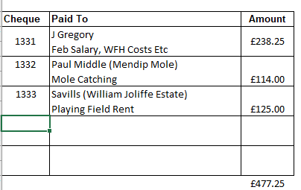

8.2 Balance on Accounts as at 31.01.24 £16659.63 which includes a VAT reclaim of £4116.42 no bank statement since February meeting therefore February reconciliation not complete.

9. Traffic/Highways/Other
  - Any items not covered in item 4.

10. Correspondence

- Any Other business

- Date of Next Meeting
10th April 2024 Annual Parish Meeting
8th May 2024 Annual Council Meeting

