I HEREBY GIVE NOTICE THAT THE ANNUAL MEETING OF THE HEMINGTON PARISH COUNCIL WILL BE HELD ON Wednesday 8th May 2024 at 7.30pm

PUBLIC PARTICIPATION

Members of the public and press are entitled to attend the meeting unless the Parish Council by resolution enters confidential session. Within this public session, members of the public may make representations, ask, and answer questions and give evidence on any matter affecting or of concern, by addressing the Chairman. Members of the public are requested to raise any matter during this session as the rest of the meeting is not open to public participation.

AGENDA

- ELECTION OF CHAIRMAN
To elect a Chairman for this municipal year. Upon his/her election, the Chairman will be invited to formally subscribe a declaration of acceptance of that office.

- ELECTION OF VICE CHAIRMAN
To elect a Vice Chairman for this municipal year. If appointed, upon his /her election, the Vice Chairman will be invited to formally subscribe a declaration of acceptance of that office.

- WELCOME & APOLOGIES
To consider any apologies for absence.

4. PARISH COUNCIL MEMBERSHIP
a. To receive any updated Register of Interests.

- DECLARATIONS OF INTEREST
To DECLARE interests, RECEIVE written dispensation requests for items of disclosable pecuniary interest and GRANT requests where appropriate. Under the Parish Council’s Code of Conduct in accordance with the Localism Act 2011 and The Relevant Authorities (Disclosable Pecuniary Interests) Regulations 2012,SI No. 1464.

- CONFIRMATION OF MINUTES
Recommended: That the minutes of the Parish Council Meeting (April 2024) are approved as a correct record and agreement given for them to be signed by the Chairman.

- CHAIRMAN’S REPORT / INTRODUCTION
To receive a short introduction from the newly appointed Chairman.

- MATTERS FROM PREVIOUS MEETING
  - Septic Tank Lid Play Park
  - Traffic Matters (CSW)
  - Play area – Matting, Bench, tractor, swing gate
  - Defibrillator – sizing / location considerations
  - Telephone box.

- PLANNING MATTERS FOR CONSIDERATION
Update on Enforcement matters at Chickwell Lane Holiday Let.

To consider the following planning applications:
None as at 01.05.24

10. FINANCES
To present current financial statement and balance on accounts, no statement received balance as at 31.03.24 £ - no statement received in time for meeting.

To agree schedule of payments as indicated below:
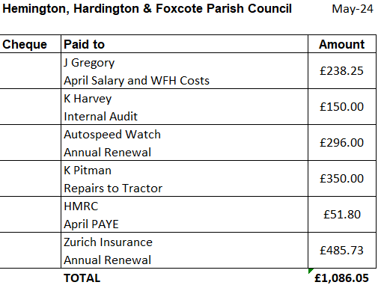

To receive YE End Accounts signed by RFO giving figures of YE balance £15440.13 income £25454 expenditure £32971

To receive Internal Auditor Report and as a result Sign off Annual Governance Return for 2023/24

To set period of public notice for annual inspection period; suggested dates 3rd June to 12th July 2024

To make changes to any Bank Mandate or banking arrangements as necessary.

10. REPORTS
Report by Somerset Councillor
Report by Chairman

11. INTERNAL CONTROL / OPERATING PROCEDURES
a. To review the following and confirm fit for purpose:
• Standing Orders • Financial Regulations • Asset Register • Risk Assessment / Risk Management Schedule
b. To confirm that the Parish Council is compliant with the Data Protection Act 2018, Freedom of Information Act 2000 and confirm that there have been no FOI requests for the 2020/21 financial year.

12. OTHER BUSINESS REFERRED TO THE CLERK
Vacancy for Councillor
Allocation of Councillor responsibilities and any assistance or sub-Committees needed.

13. MATTERS OF REPORT AND TO BE REFERRED TO NEXT MEETING

14. DATES OF FURTHER MEETINGS
To agree Full Council meeting dates for the coming year including:

Half yearly budget considerations (suggested September) and the 2025 Annual Parish Meeting (suggested May 2024)
Close

