**I HEREBY GIVE NOTICE THAT A FULL MEETING OF THE HEMINGTON PARISH COUNCIL WILL BE HELD ON Wednesday 9th April 2025 to follow Annual Parish Meeting held at 7pm**

**PUBLIC PARTICIPATION**

Members of the public and press are entitled to attend the meeting unless the Parish Council by resolution enters confidential session. Within this public session, members of the public may make representations, ask, and answer questions and give evidence on any matter affecting or of concern, by addressing the Chairman. Members of the public are requested to raise any matter during this session as the rest of the meeting is not open to public participation. This session is limited to 15 minutes.

**AGENDA**

1. **WELCOME & APOLOGIES**

To consider any apologies for absence.

1. **DECLARATIONS OF INTEREST**

To DECLARE interests, RECEIVE written dispensation requests for items of disclosable pecuniary interest and GRANT requests where appropriate. Under the Parish Council’s Code of Conduct in accordance with the Localism Act 2011 and The Relevant Authorities (Disclosable Pecuniary Interests) Regulations 2012,SI No. 1464.

1. **PUBLIC SESSION**
2. **CONFIRMATION OF MINUTES**

Recommended: That the minutes of the Full Council Meeting (March 25) are approved as a correct record and agreement given for them to be signed by the Chairman.

1. **CHAIRMAN’S REPORT / INTRODUCTION**

Monthly activity report.

1. **MATTERS FROM PREVIOUS MEETING**
   1. A366 update
   2. ASW / CSW update
   3. Feasibility Study response and costs
   4. Dog and litter Bins – installed ?
   5. Grove road By-way (fly tipping and vehicle issues) reported reference 80067
   6. Moles – Completed
2. **PLANNING MATTERS FOR CONSIDERATION**

To consider the following planning applications:

Applications for consideration: Extensions granted to 11th April

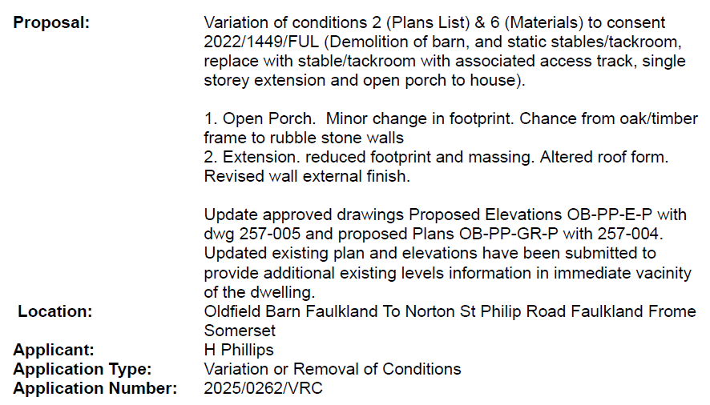

**10. FINANCES**

a. To present current financial statement and balance on accounts at Year End

b. To agree schedule of payments as indicated below:

J Gregory Salary & Expenses £262.99 (net)

HMRC PAYE £283.95

Village Hall Grant Payment £2500.00

Glasdon Dog and Litter Bin £304.72

c. Year end underway noting that we will fall back into the exemption category for the 24/25 financial year.

d. Cllr Suzi Cross added to list of signatories for online banking

**11. REPORTS**

a. Report by Somerset Councillor (Circulated)

b. Crime Report (circulated)

1. **OTHER BUSINESS REFERRED TO THE CLERK**

ACV – The Faulkland Inn

Chain Harrow of the playing field

Telephone box – glass and painting

**12. MATTERS OF REPORT AND TO BE REFERRED TO NEXT MEETING**

**13. DATES OF FURTHER MEETINGS**

## May 14th at 7.30pm

Note: Clerk on Jury Service from 22nd April for 10 days

**Close**