Hemington, Hardington
& Foxcote Parish Council
Chairman: Ian Biggerstaff ianbigg01@gmail.com
Clerk: Jen Gregory 07912177288 clerk.hemingtonpc@gmail.com
______________________________________________________________________
M I N U T E S
Of Hemington, Hardington & Foxcote Parish Council
Held on Wednesday 9th April 7.30pm at Faulkland Village Hall

Present: Cllrs Biggerstaff, Francis, Cross, Buckwell and Hanley

Also Present: Somerset Cllr B Clarke,J Gregory Proper Officer plus 11 Members of the public

Public Participation
Matters raised;
All residents in attendance spoke of their unhappiness with the pub development. We heard of the well attended events and reasons why Faulkland was chosen as a place to live along with its heritage and meaning for a village.

24/25 113 Welcome and apologies for absence
All in attendance

24/25 114 Declarations of Interest
Resolved: No declarations advised for tonight’s meeting.

24/25 115 Minutes of the Previous Meeting
To receive the minutes of the meeting held 12th March 2025
Resolved: Minutes of the previous meeting was signed by the Chairman as a correct record in the presence of the Proper Officer and meeting attendees

24/25 116 Report from Somerset Councillor B Clarke
Cllr Clarke advised that parking within the county was current out for consultation with the view to make charges uniform across the whole of Somerset.

Tree planting saw 140 trees planted. The target was 240 hectares per year.

The household relief fund would be continuing for a further year.

Property assets at Somerset were being sold to pay for the capitalisation grant. 66% of council tax was to go to adult social care although this figure was nearer 70%.

24/25 117 Matters Arising from Previous Meeting
    - A366 TAG Group
As per the APM following the visit from Anna Sabine MP a response was awaited from Somerset.

    - CSW/ASW
Current progress covered in APM with the SID fund awaited into the bank account without this funding being present the SID’s could not be purchased.

iii) Dog Bins/ Litter bin have been delivered V Curtis – the litter bin was installed and dog bin imminent.

iv) Grove Lane Bridleway was reported for fly tipping and vehicle access – this was on the system as a medium priority therefore ongoing.

v) The moles were completed and recommended that the field chain-harrowed. Council felt this not necessary and mole dirt would be scattered naturally.

vi) Enquiries of traffic indicated that the feasibility study would cost £500 with the actual move to 20mph costing no more than 10k. It was proposed by Cllr Buckwell and seconded Cllr Cross to progress this. A vote was taken with 3 in favour and 2 abstentions.
Resolved: Clerk to progress Feasibility Study with Traffic with a request that the Council be advised when they are coming.

vii) Fulwell Lane flooding has been inspected and action taken.

viii) Resident at Hemington complained of collapsed drain. Cllr Francis indicated this had been addressed and repaired.

viii) Cllr Biggerstaff stated that a litter pick had been completed and thanks expressed to those who came out. It was suggested that this be carried out twice yearly in March and September.

ix) Clerk to ask T Hucker reference the telephone box maintenance.

24/25 118 Planning Matters for Consideration
To consider the following planning applications:
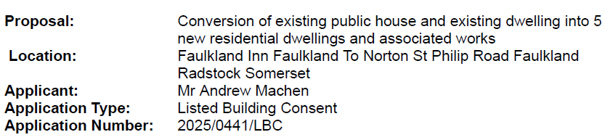

- Noted that there was a further application 2025/0440/FUL for the above

Resolved: Council to not recommend: the division of the existing rooms into smaller rooms is detrimental to the character of the building, information contained in the application is insufficient to show how they would deal with internal details. The Council took the views of the residents into consideration when making this decision. It was voted to not recommend with 5 votes in favour (both applications)
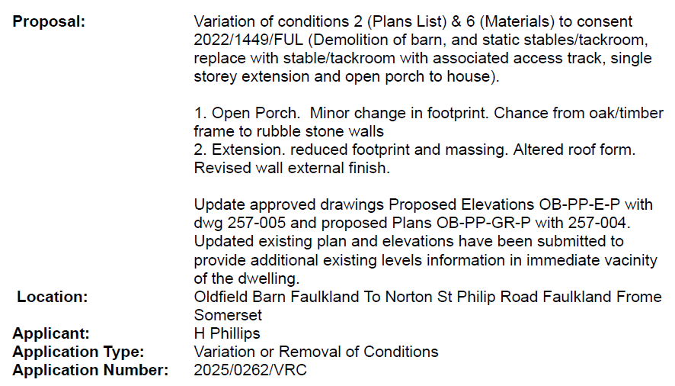
Resolved: Council Recommended approval of this application. Voted 5 for, 0 against.

24/25 119 Finances
- To present current financial statement and balance on accounts 31.03.25 YE £21615.70

- To agree schedule of payments as indicated below:
J Gregory Salary & Expenses £277.99 (net)
HMRC PAYE £283.95
Village Hall Grant Payment £2500.00
Glasdon Dog and Litter Bin £304.72
Village Hall Payment held until payment of precept 2025/6

- Year end underway noting that we will fall back into the exemption category for the 24/25 financial year.

- Cllr Suzi Cross being progressed to the signatories for online banking

- The Clerk advised the time line with regard to the year end. YE completed by the Clerk and now at the internal Auditor –

24/25 120 Other business Referred to the Clerk
For information the following action had been taken via a round robin email.
Proposal: Temporary change of use of land from agricultural to dog
training/showing field for 50 days per calendar year & formation of
farm track.
Location: Upper Row Farm Row Lane Laverton Frome Somerset
Applicant: E Hendy
Application Type: Full Application
Application Number: 2025/0289/FUL
Comments are welcome by 28th March 2025.
This was not an agenda item so a round robin was necessary. There was nothing contentious about the application so Councillors felt no extension was necessary.
Resolved : Council Recommended approval

Jury Service had been moved to June for the Clerk.

24/25 121 Matters for consideration at the Next Meeting.

24/25 122 Date of the next Meeting

13th May 2025

Attendees were thanked for their contribution and attendance.

Meeting closed 9.05pm

A signed copy of the minutes can be viewed by arrangement via the Parish Clerk.

