I HEREBY GIVE NOTICE THAT A FULL MEETING OF THE HEMINGTON PARISH COUNCIL WILL BE HELD ON Wednesday 10th December 2025, 7.30pm

PUBLIC PARTICIPATION

Members of the public and press are entitled to attend the meeting unless the Parish Council by resolution enters confidential session. Within this public session, members of the public may make representations, ask, and answer questions and give evidence on any matter affecting or of concern, by addressing the Chairman. Members of the public are requested to raise any matter during this session as the rest of the meeting is not open to public participation. This session is limited to 15 minutes.

AGENDA

- WELCOME & APOLOGIES
To consider any apologies for absence.

- DECLARATIONS OF INTEREST
To DECLARE interests, RECEIVE written dispensation requests for items of disclosable pecuniary interest and GRANT requests where appropriate. Under the Parish Council’s Code of Conduct in accordance with the Localism Act 2011 and The Relevant Authorities (Disclosable Pecuniary Interests) Regulations 2012,SI No. 1464.

- PUBLIC SESSION

- CONFIRMATION OF MINUTES
Recommended: That the minutes of the Full Council Meeting (November 25) are approved as a correct record and agreement given for them to be signed by the Chairman.

- CHAIRMAN’S REPORT / INTRODUCTION
Monthly activity report.

- MATTERS FROM PREVIOUS MEETING
  - A366 update
  - ASW / CSW update
Update from Chair of SID Location request
  - Grasscutting – 2 cuts per month requested
  - Polycarbonate – Vince requested for noticeboards
  - SID warranty – Effective from delivery date cannot be changed

- PLANNING MATTERS FOR CONSIDERATION
To consider the following planning applications (Extension granted) :
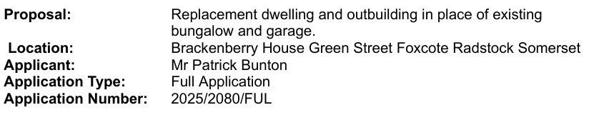
8. FINANCES
a. To present current financial statement and balance on accounts as at 31.11.25 £43212.33

b. To agree schedule of payments as indicated below:
J Gregory Salary £262.99
HMRC PAYE Liability £58.00
Town and Parish Websites Annual Website hosting £190.00
SALC Training Inv2271 £40.00
Elan City SIDs £5615.98
GB Sport and Leisure Annual Inspection £114.00

c. Budget preparations (attached)

9. REPORTS
a. Report by Somerset Councillor (Circulated)

10. OTHER BUSINESS REFERRED TO THE CLERK
Play Inspection Report (attached)

11. MATTERS OF REPORT AND TO BE REFERRED TO NEXT MEETING

12. DATES OF FURTHER MEETINGS
13th January 2026
Close

