Hemington, Hardington
& Foxcote Parish Council
Chairman: Ian Biggerstaff: ibhemingtonpc@gmail.com
Clerk: Jen Gregory 07912177288 clerk.hemingtonpc@gmail.com
______________________________________________________________________
M I N U T E S
Of Hemington, Hardington & Foxcote Parish Council (Annual Council)
Held on Wednesday 14th January 2026 7.30pm at Faulkland Village Hall

Present: Cllrs Biggerstaff, Buckwell, Green, Cross, Hanley, Francis

Also Present: J Gregory Proper Officer plus 8 Members of the public

25/26 073 Welcome and apologies for absence
Cllr Green was at the Christmas Market in Bath with the Lavender business.
Resolved: Apologies accepted by the meeting

Public Participation
Matters raised;
Planning concerns include flooding, water drainage to the pond, amenity impacts, infrastructure strain, and access issues at a blind bend. Residents, including those not listed as consultees, are encouraged to submit objections, as varied feedback is valuable.
25/26 074 Declarations of Interest
Cllr Green declared an interest in Planning item 7 on the agenda and removed himself from discussions and voting

25/26 075 Minutes of the Previous Meeting
To receive the minutes of the meeting held December 2025 along with Confidential Minutes
Resolved: approved and signed in the presence of the meeting.

25/26 076 Report from Chair
Nothing to report other than matters listed in agenda.

25/26 077 Report from Somerset Councillor B Clarke
No Councillor Clarke in attendance but a report circulated prior to Christmas.
25/26 078 Matters Arising from Previous Meeting
    - A366 TAG Group
A letter was sent to Gary Warren accepting the 50mph offer and requesting clarification on other items. Two posts were installed near the adverse camber, likely for signage, but one was knocked out in a two-car incident.
    - CSW/ASW
ASW – Tim Gibbs reported that the vehicle-activated sign on the east end is operational; however, there are ongoing battery issues. One ASW unit has been replaced or upgraded to Version 2 at Tim Gibbs' expense.
Poor weather has hampered CSW activity, but members are encouraged to participate whenever possible to avoid removal from the Scheme. Paul is currently unable to join, and it was reported the BANES CSW Coordinator has stepped down due to ongoing frustrations.
iii) Noticeboards
Costs provided to go for an 8 copy board in black powder coating. The old board may be useful to recycle back to the Village Hall.

vi) The installation of SIDS has been delayed due to challenging locations. Cllr Buckwell’s neighbour offers a suitable site at one end of the village, which Cllr Biggerstaff will pursue. At the other end, private land is available, but the pavement is too narrow for a pole to allow pedestrian safety.

White lines were mentioned – Clerk to follow up with Traffic (Sara Davis)
25/26 079 Planning Matters for Consideration
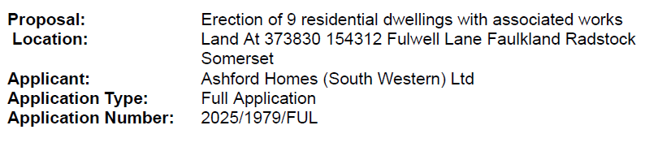
Resolved: Recommend refusal Vote taken 4 unanimously (without Chair and Cllr Green) – Clerk to provide summary information in draft before submission.

25/26 080 Finances
- Bank Reconciliation as at 31.12.25 £36925.36

- To agree schedule of payments as indicated below:
J Gregory Salary £262.99
HMRC PAYE Liability £58.00
Francis Green Reimbursement of Christmas Tree Stand £ 39.98

Resolved: Proposed Cllr Hanley and seconded Cllr Francis with all in agreement to accept the payment schedule.

- Budget session moved to a confidential session in a closed meeting

25/26 081 Other business Referred to the Clerk
SCRAPP – To look into the group Somerset Communities Raging Against Poor Planning

The Bridleway was blocked off the Green; the clerk checked with planning. After the meeting, she learned Highways had inspected and would be followed up.
Planters – Cllr Buckwell proposed Council funding for planters at one or both ends of the village. The idea was approved, with traffic notification to be coordinated by Cllr Buckwell through the Clerk. Cllr Hanley stated that white gates may be a nice addition to be looked at in the future.
25/26 082 Any Other Business
Thanks expressed to Ammerdown for donation of the Christmas Tree.

25/26 083 Matters for consideration at the Next Meeting.

25/26 084 Date of the next Meeting
11th February 2026
Meeting closed to the public 8.30pm
A confidential session was held to discuss precept.
25/26 086 Precept
Resolved: to increase precept by 5% equating to £25743.38 – Proposed Cllr Biggerstaff, seconded Cllr Cross with all members in agreement.
Attendees were thanked for their contribution and attendance.

Meeting closed 8.48pm

A signed copy of the minutes can be viewed by arrangement via the Parish Clerk.

