I HEREBY GIVE NOTICE THAT THE ANNUAL COUNCIL MEETING OF THE HEMINGTON PARISH COUNCIL WILL BE HELD ON Wednesday 13th May 2026, to follow Annual Parish Meeting

PUBLIC PARTICIPATION

Members of the public and press are entitled to attend the meeting unless the Parish Council by resolution enters confidential session. Within this public session, members of the public may make representations, ask, and answer questions and give evidence on any matter affecting or of concern, by addressing the Chairman. Members of the public are requested to raise any matter during this session as the rest of the meeting is not open to public participation. This session is limited to 15 minutes.

AGENDA

- TO APPOINT A CHAIRMAN

- TO APPOINT A VICE CHAIRMAN

- WELCOME & APOLOGIES
To consider any apologies for absence.

- DECLARATIONS OF INTEREST
To DECLARE interests, RECEIVE written dispensation requests for items of disclosable pecuniary interest and GRANT requests where appropriate. Under the Parish Council’s Code of Conduct in accordance with the Localism Act 2011 and The Relevant Authorities (Disclosable Pecuniary Interests) Regulations 2012,SI No. 1464.

- PUBLIC SESSION

- CONFIRMATION OF MINUTES
Recommended: That the minutes of the Full Council Meeting (April 26) are approved as a correct record and agreement given for them to be signed by the Chairman.

- CHAIRMAN’S REPORT / INTRODUCTION
Monthly activity report.

- MATTERS FROM PREVIOUS MEETING
  - A366 update
  - ASW / CSW update
  - SIDs – Update
  - Wifi/ hot spot – Costs and details
  - Noticeboard – delivered
  - Training – NSP joint venture Chair to update
  - Community Wellbeing – update if needed.
  - Litter Pick - update

- PLANNING MATTERS FOR CONSIDERATION
To consider the following planning applications : Extension granted
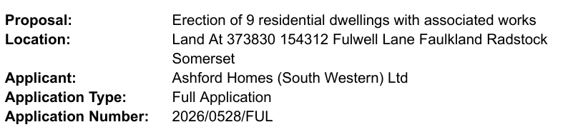

8. FINANCES
a. To present current financial statement and balance on accounts £48914.86 (received VAT reimbursement of £1271.54, Wellbeing grant £1000.00 and 1st payment of precept £12871.69)

b. To agree schedule of payments as indicated below:
J Gregory Salary £288.39
Zurich Insurance Annual Renewal £543.56
Trug and Lettuce Grasscutting £450.00

c. To set accounting inspection period and update on audit. Suggest inspection period 3rd June to 14th July.

9. REPORTS
a. Report by Somerset Councillor (Circulated)

10. OTHER BUSINESS REFERRED TO THE CLERK

11. MATTERS OF REPORT AND TO BE REFERRED TO NEXT MEETING

12. DATES OF FURTHER MEETINGS
10th June 2026 at 7.30pm

Close

