I HEREBY GIVE NOTICE THAT THE FULL COUNCIL MEETING OF THE HEMINGTON PARISH COUNCIL WILL BE HELD ON Wednesday 23rd September 2026 7.30pm

PUBLIC PARTICIPATION

Members of the public and press are entitled to attend the meeting unless the Parish Council by resolution enters confidential session. Within this public session, members of the public may make representations, ask, and answer questions and give evidence on any matter affecting or of concern, by addressing the Chairman. Members of the public are requested to raise any matter during this session as the rest of the meeting is not open to public participation. This session is limited to 15 minutes.

AGENDA

- WELCOME & APOLOGIES
To consider any apologies for absence.

- DECLARATIONS OF INTEREST
To DECLARE interests, RECEIVE written dispensation requests for items of disclosable pecuniary interest and GRANT requests where appropriate. Under the Parish Council’s Code of Conduct in accordance with the Localism Act 2011 and The Relevant Authorities (Disclosable Pecuniary Interests) Regulations 2012,SI No. 1464.

- PUBLIC SESSION

- CONFIRMATION OF MINUTES
Recommended: That the minutes of the Full Council Meeting (Jully 26) are approved as a correct record and agreement given for them to be signed by the Chairman.

- CHAIRMAN’S REPORT / INTRODUCTION
Monthly activity report.

- MATTERS FROM PREVIOUS MEETING
  - A366 update
  - ASW / CSW update
  - SIDs – Update. Advised to Sara Davis of location – installation during financial year
  - Wifi/ hot spot
  - Noticeboard
  - Community Wellbeing – Decision on Parish Plan required
  - Maintenance of the benches on the Green / other public amenitites - update
  - Pond maintenance and improvement – update
  - Ammerdown Crossroads – under review with Road Safety Team

- PLANNING MATTERS FOR CONSIDERATION
Notification Only
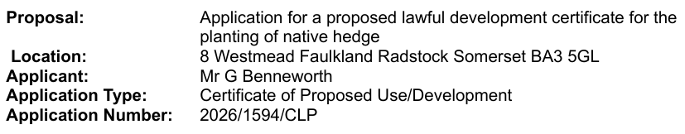
To consider the following planning applications : Extensions granted
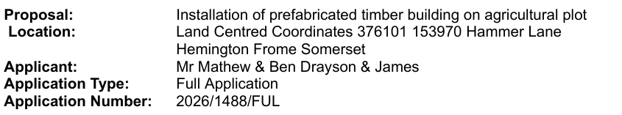

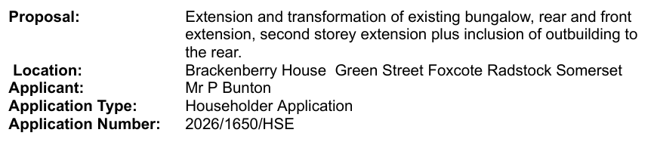

Ratification of decision:
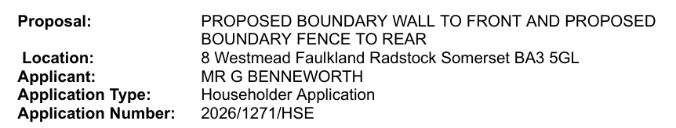

Decisions on the following
2026/0891 Carpenters Paddock – approved
2026/1448 1 Lavendar Close – approved
2026/1271 8 Westmead – approved

8. FINANCES
a. To present current financial statement and balance on accounts 31st August £39590.30. Note 2nd payment of precept received in early September not including in above figures.

b. Payments agreed and made during August.
J A Gregory Salary £288.19
HMRC PAYE £ 64.40
Trug & Lettuce Grasscutting £325.00

c. To agree schedule of payments as indicated below:
J A Gregory Salary £288.19
Fasthosts Web Hosting £ 87.64 Reimburse Clerk
HMRC PAYE £ 64.20
Refreshments Community engagement £206.40
Trug & Lettuce June Invoice (missed) £450.00

9. REPORTS
a. Report by Somerset Councillor

10. OTHER BUSINESS REFERRED TO THE CLERK
a. Subject Access Request/
request for information Environmental Information Regulations 2004 (EIR)
b. Car parking on junction Grove Lane – Cllr Francis
c. Grant Village Hall

11. MATTERS OF REPORT AND TO BE REFERRED TO NEXT MEETING

12. DATES OF FURTHER MEETINGS
14th October 2026

Close

